**ENVIRONMENT RESOURCES AND DEVELOPMENT COURT**

**No. 106 of 2010**

BETWEEN

**RICHARD PALTRIDGE, THOMAS PALTRIDGE and LOUISE PALTRIDGE**

AND

**DISTRICT COUNCIL OF GRANT**

AND

**ACCIONA ENERGY OCEANIA PTY LTD**

**GARY ALLEN WITTERT**

**ANALYSIS OF PERSONAL JOURNAL RECORDINGS, AS PROVIDED BY DR SARAH LAURIE, OF MORNING BLOOD PRESSURE IN RELATION TO WIND TURBINE OUTPUT, OF THREE INDIVIDUALS LIVING WITHIN 5KM OF WAUBRA WIND FARM**

1. **Process followed (Methodology)**
2. **Analysis of data from AR**
3. **Analysis of data from GW**
4. **Analysis of data from BMJ**
5. **Comment on the data.**
6. **Methodology**
   1. Personal journal records of blood pressure (BP) for five individuals were provided by Dr Sarah Laurie.
   2. Three of these records were from individuals (AR, GW and BMJ) with clearly elevated blood pressure (≥140/90).
   3. The BP recorded first thing each morning was tabulated in Statistical Package for the Social Science (SPSS) version 17. Systolic and diastolic BPs were entered in separate columns.
   4. The mean overnight output from the turbines as provided in Appendix 6 of the document provided by Dr Laurie was recorded in a separate column.
   5. The audibility of the turbines as recorded by one individual (AR) was also tabulated.
   6. Line graphs of systolic and diastolic blood pressure for each morning were plotted together with the average power output of the turbines over the preceding night (2.1, 3.1, and 4.1).
   7. Dot plots relating, separately, waking systolic and diastolic, blood pressure to mean overnight turbine power output were drawn, and a regression line fitted and these are presented for each individual (2.2, 2.3; 3.2, 3.3; 4.2;4.3).
   8. A line graph of systolic and diastolic blood pressure for each morning was plotted together with the audibility of the turbine at the time the blood pressure was recorded (2.4).
7. **Data for AR**

**2.1**

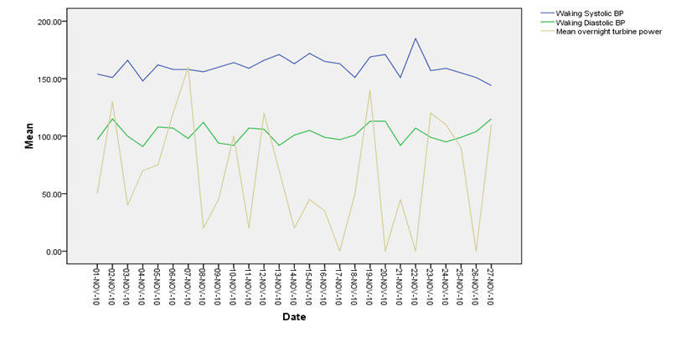

**2.2**

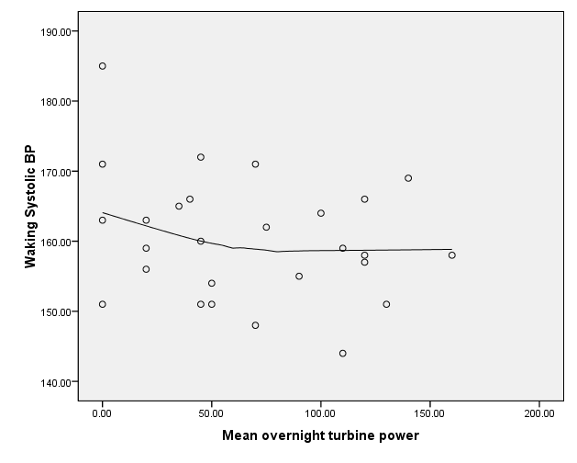

**2.3**

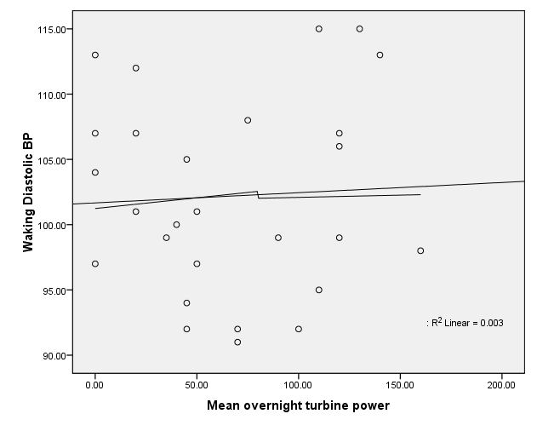

**2.4**

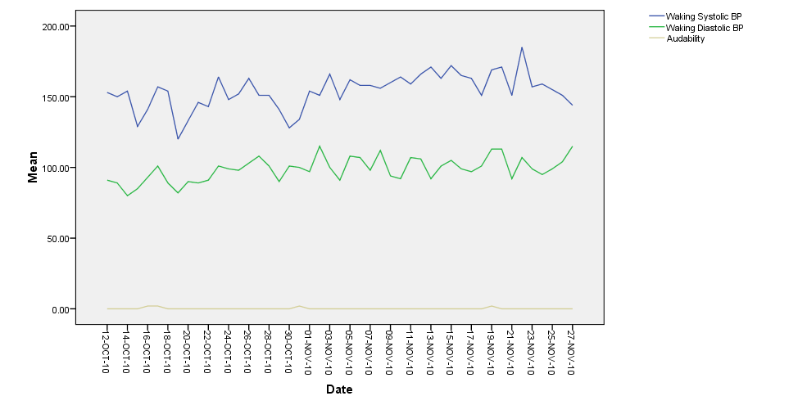

1. **Data for GW**

**3.1**

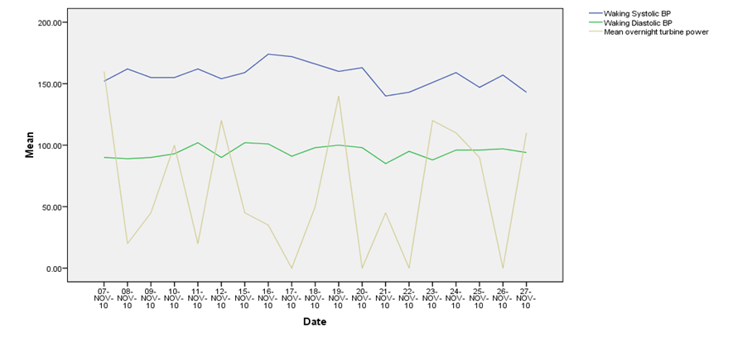

**3.2**

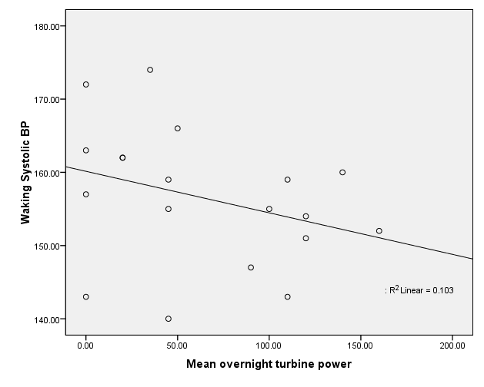

**3.3**

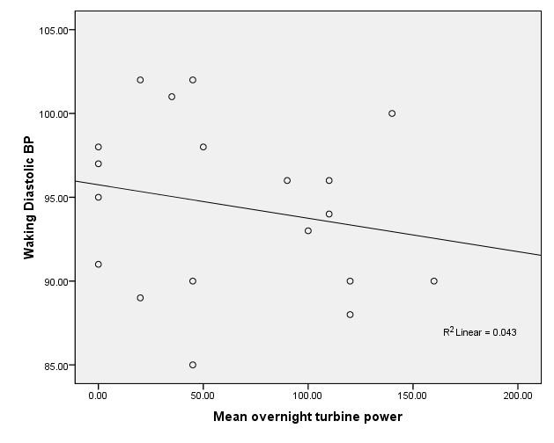

1. **Data for BMJ/BJ**

**4.1**

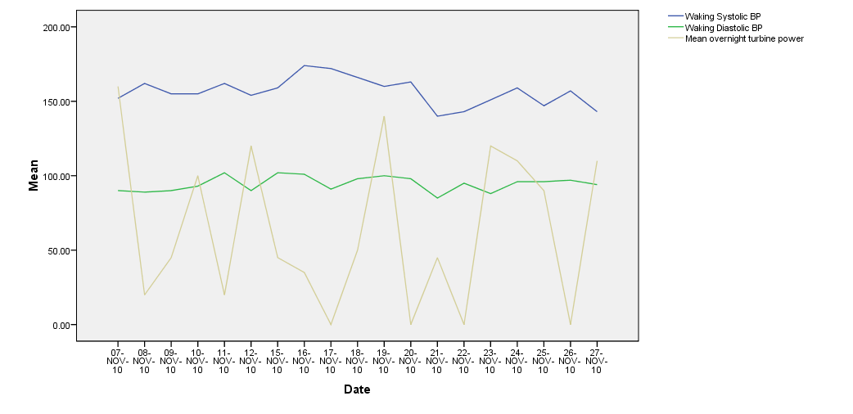

**4.2**

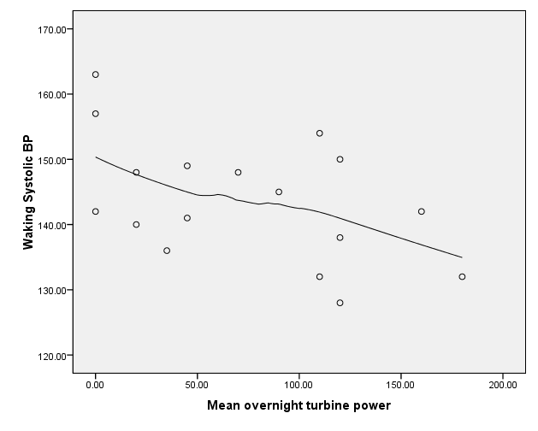

**4.3**

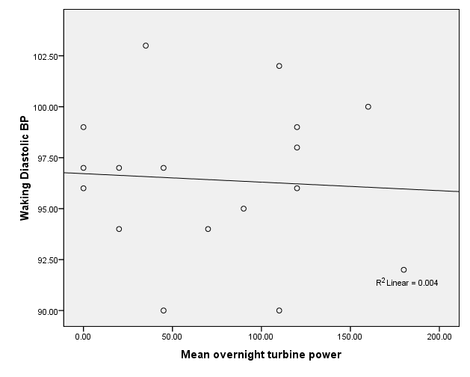

1. **Comment**

These data are inconsistent with any assertion that the output from wind turbines has an adverse effect on blood pressure.